asian storytelling network
REGISTRATION FORM
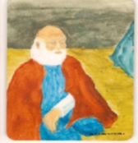
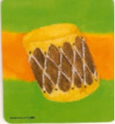

©OH Publishing
OH! Storytelling for Helping & Healing
Saturday Apr 13, 2019
9:30am – 12:30pm
Name/s
Email/s
Organization
Tel
Mobile
Form Of Payment  $100/- per seat |  | By Cheque No. ____________________ for $ _____________
 | . | Cash or other means (IFAS, PayLah! or PayNow)
Note | - Book early - limited seats available.  - Cancellations: non-refundable but transferable.  - Should the session be cancelled by the organiser, registration payments will be refunded.  - Confirmation via e-mail upon receipt of registration with payment.  - OH card deck resources will be made available for sale on the day.  - Payment for resources by cheque, cash, DBS PayLah! or PayNow.  - Invoices/receipts will be issued.  - Registration forms may either mailed, faxed or emailed.
Mail To | Payment (if by cheque) made in favour of “Asian Storytelling Network” to be mailed to:  Asian Storytelling Network  Blk 10M #01-51, Braddell Hill  Singapore. 579731

